Huỳnh Ngọc Quang – SE181838

NWC204 - dunglt92

Lab - View Wired and Wireless NIC Information

# Instructions

## Identify and Work with PC NICs.

In Part 1, you will identify the NIC types in the PC that you are using. You will explore different ways to extract information about these NICs and how to activate and deactivate them.

**Note**: This lab was performed using a PC running on the Windows 10 operating system. You should be able to perform the lab with one of the other Windows operating systems listed; however, menu selections and screens may vary.

### Use the Network and Sharing Center.

* + - 1. Navigate to the **Control Panel**. Click **View network status and tasks** under Network and Internet heading in the Category View.
      2. In the left pane, click the **Change adapter settings** link.
      3. In the Network Connections window, the results provide a list of NICs available on this PC. Look for your Wi-Fi adapters.

**Note**: Virtual Private Network (VPN) adapters and other types of network connections may also be displayed in this window.

### Work with your wireless NIC.

* + - 1. Locate the wireless network connection. If it is disabled, right-click and select **Enable** to activate your wireless NIC.
      2. If the wireless network connection is not currently connected, right-click and select **Connect/Disconnect** to connect to an SSID that you are authorized to connect to.
      3. Right-click a wireless network connection, and then click **Status**.
      4. The wireless network connection **Status** window displays where you can view information about your wireless connection.

#### Questions:

What is the Service Set Identifier (SSID) for the wireless router of your connection?

FPTU_Student

What is the speed of your wireless connection?

300Mbps

* + - 1. Click **Details** to display the Network Connection Details window.

#### Questions:

What is the MAC address of your wireless NIC?

A2-87-87-85-32-2F

Do you have multiple IPv4 DNS Servers listed? If so, why would multiple DNS Servers be listed?

Yes. Several DNS Servers are provided as alternatives in case the initial DNS server encounters issues such as maintenance or technical problems. If the primary DNS server is unavailable or unresponsive, the subsequent DNS servers are employed in sequence.

* + - 1. Open a Windows Command Prompt and type **ipconfig /all**.

Open a Windows Command Prompt.

Notice that the information displayed here is the same information that was displayed in the Network Connection Details window in Step e.

* + - 1. Close the command window and the Network Connection Details window. This should return you back to the Wi-Fi **Status** window. Click **Wireless Properties**.

Close a Windows Command Prompt.

* + - 1. In the **Wireless Network Properties** window, click the **Security** tab.
      2. The type of security the connected wireless router has implemented displays. Click the **Show characters** check box to display the actualNetwork security key, instead of the hidden characters, and then click **OK**.

* + - 1. Close the Wireless Network Properties and the Wi-Fi Status windows. Select and right-click the **Wi-Fi** option > **Connect/Disconnect**. A pop-up window should appear at the bottom right corner of your desktop that displays your current connection, along with a list of SSIDs that are in range of the wireless NIC of your PC. If a scrollbar appears on the right side of this window, you can use it to display additional SSIDs.
      2. To join one of the other wireless network SSIDs listed, click the SSID that you want to join, and then click **Connect**.

* + - 1. If you have selected a secure SSID, you are prompted to enter the **Security key** for the SSID. Type the security key for that SSID and click **OK**. You can click the **Hide characters** check box to prevent people from seeing what you type in the **Security key** field.

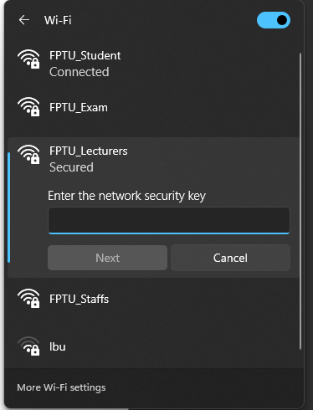 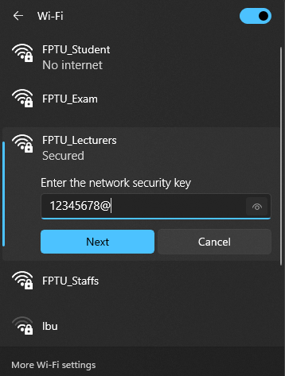

### Work with your wired NIC.

## Identify and Use the System Tray Network Icons

In Part 2, you will use the network icons in your system tray to determine and control the NICs on your PC.

### Use the network icon.

* + - 1. Click the system tray. Click the network icon to view the pop-up window that displays the SSIDs that are in-range of your wireless NIC.

* + - 1. Click **Network & Internet**.
      2. In the Settings windows, click **Change adapter options** under the Change your network settings heading.
      3. In the Network Connections window, right-click **Wi-Fi** and select **Disable**.
      4. Examine your system tray. Click the **Network** icon again. With the Wi-Fi disabled, wireless networks are no longer in range and not available for wireless connections.
      5. You can also disable the Ethernet network by disabling the Ethernet adapters.

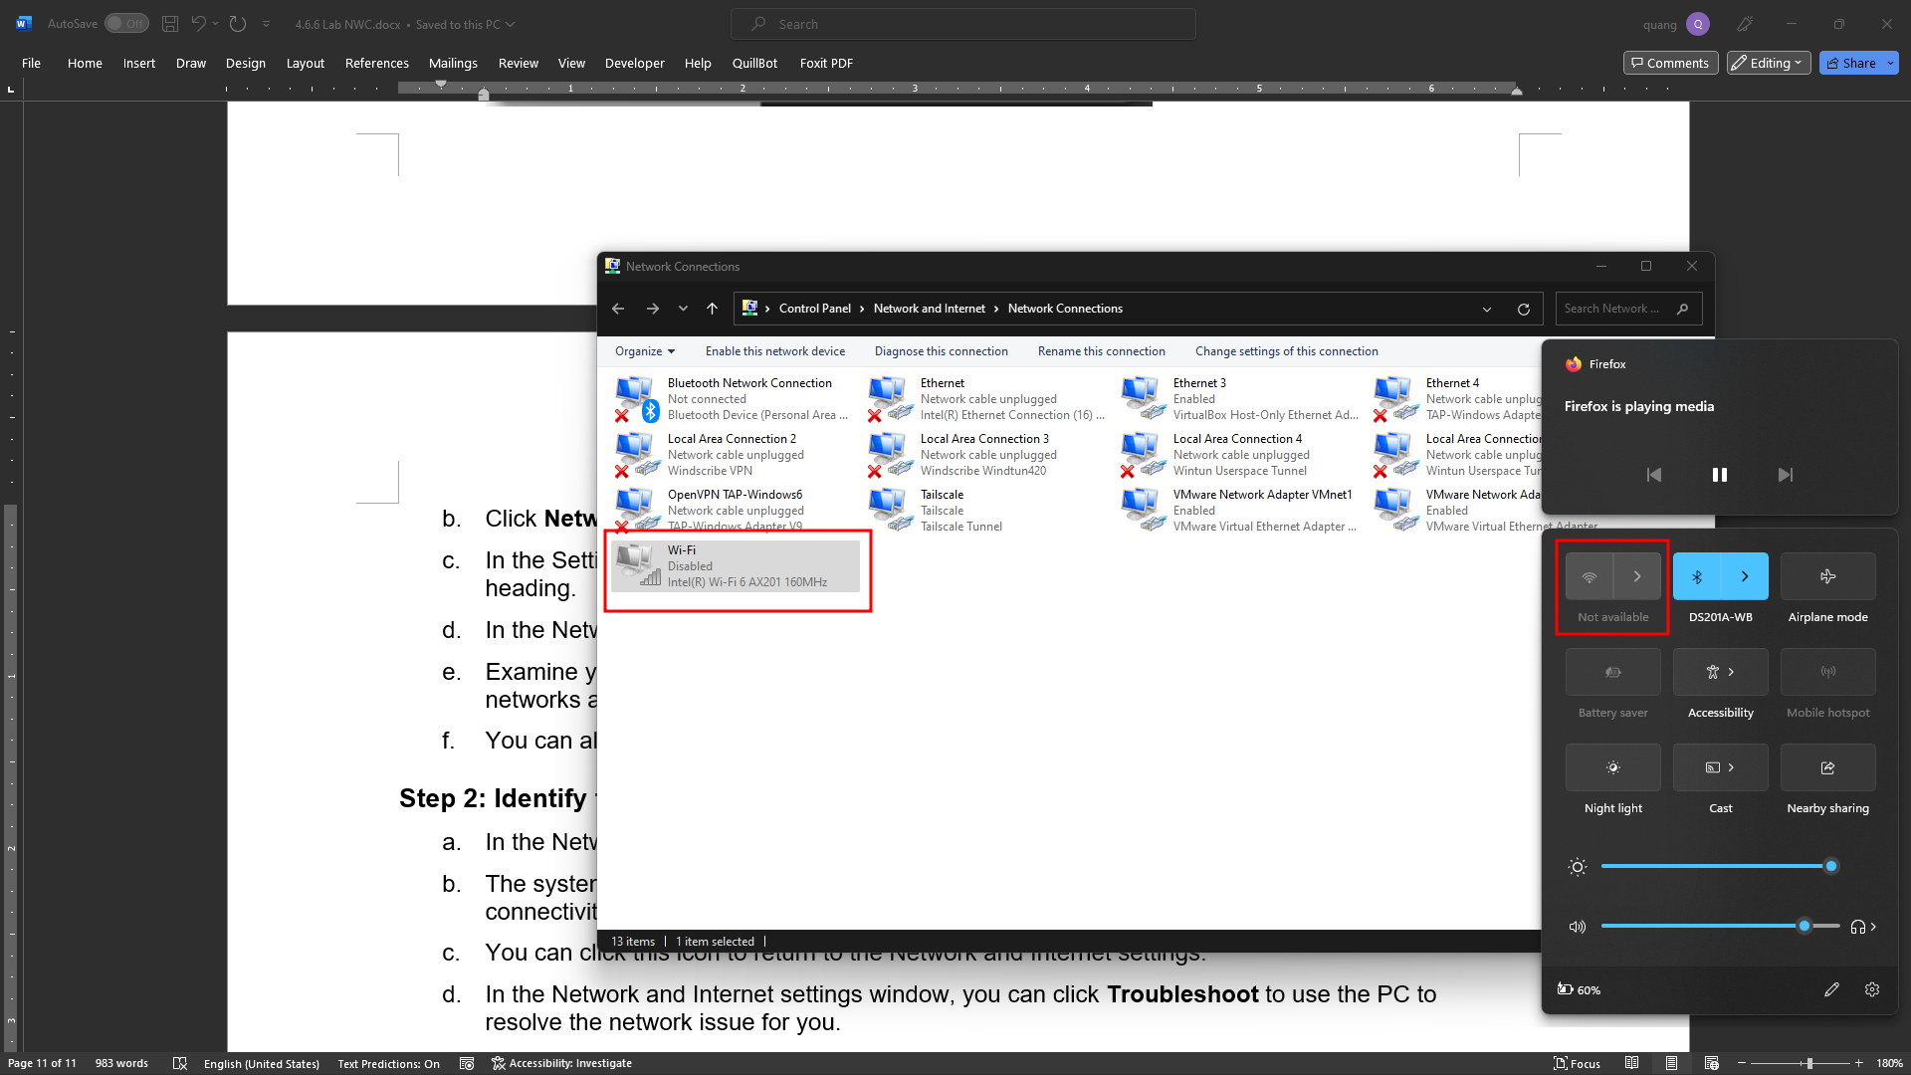

### Identify the Network Problem icon.

* + - 1. In the Network Connections window, disable all the **Wi-Fi** and **Ethernet** adapters.
      2. The system tray now displays the **Network Disabled** icon, which indicates that network connectivity has been disabled.
      3. You can click this icon to return to the Network and Internet settings.
      4. In the Network and Internet settings window, you can click **Troubleshoot** to use the PC to resolve the network issue for you.
      5. If troubleshooting did not enable one of your NICs, then you should do this manually to restore the network connectivity of your PC.

**Note**: If a network adapter is enabled and the NIC is unable to establish network connectivity, then the **Network Problem** icon appears in the system tray.

If this icon appears, you can troubleshoot this issue just like you did in Step 2c.

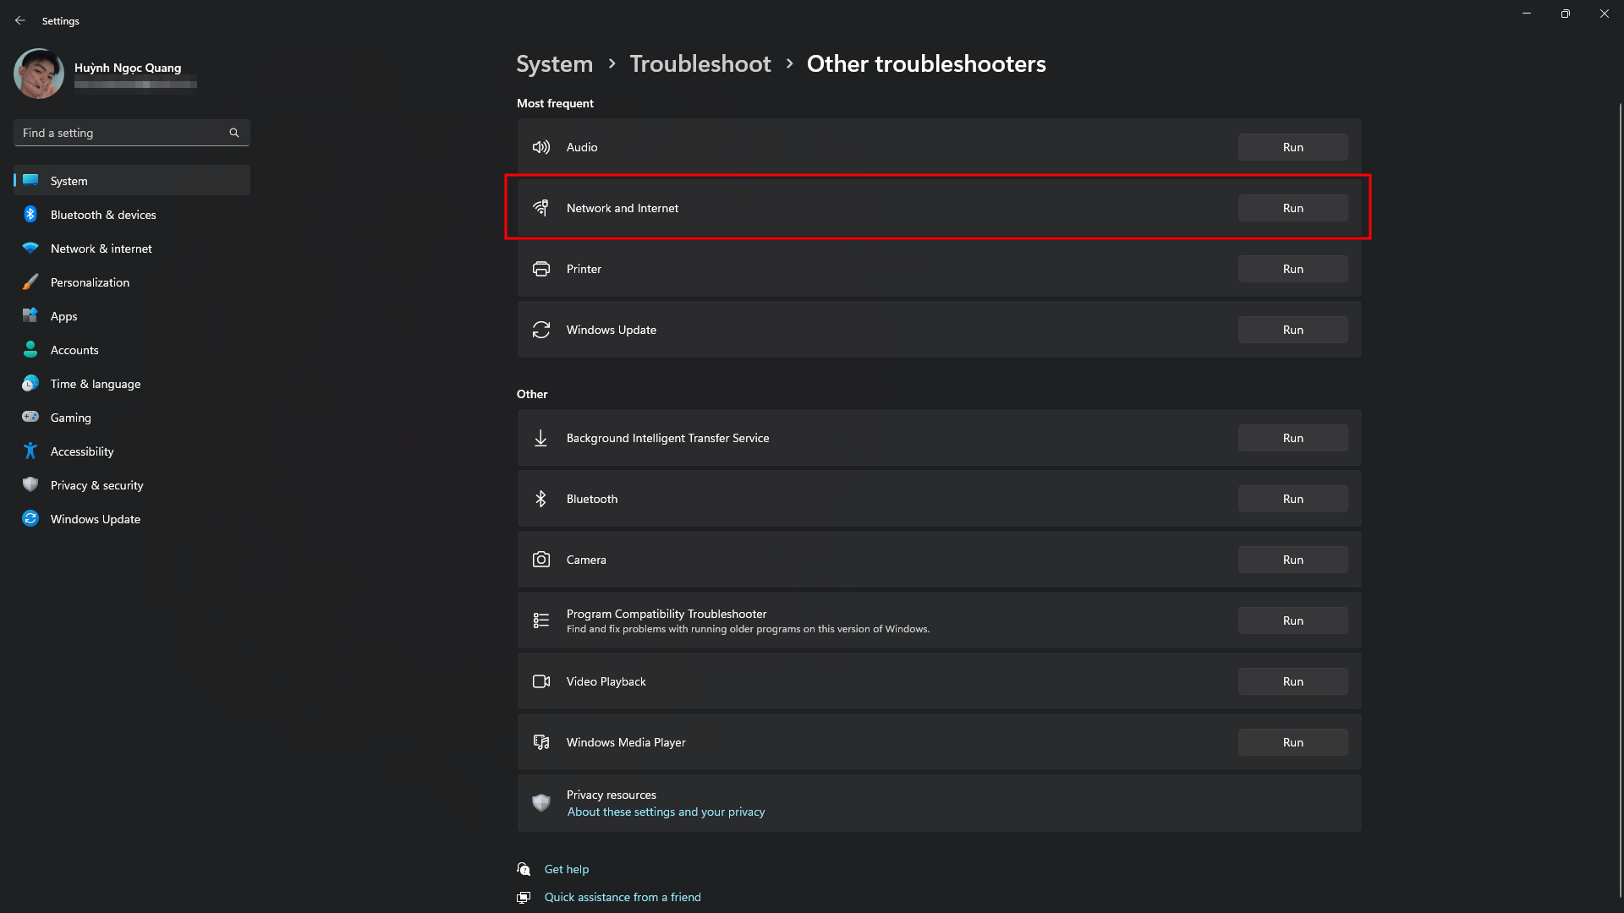

# Reflection Question

Why would you activate more than one NIC on a PC?

* Redundancy: To provide network redundancy, ensuring that if one NIC or network path fails, the computer can still communicate using the other NIC.
* Different Networks: When a PC needs to connect to different networks simultaneously, such as a corporate LAN and a VPN network.
* Specialized Tasks: Some tasks, like running a proxy server or hosting virtual machines, benefit from multiple NICs to separate or manage network traffic effectively.